Nama: Daffa Andika Ramdani

NIM: 2402012

Kelas: TI 1A

GitHub: https://github.com/dapa-28/sistem-operasi-.git

Laporan Tugas Sistem Operasi Instalasi PROXMOX;

1.

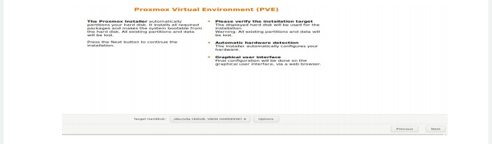

2.

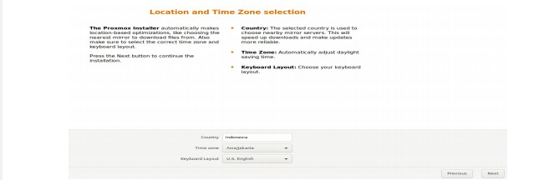

3.

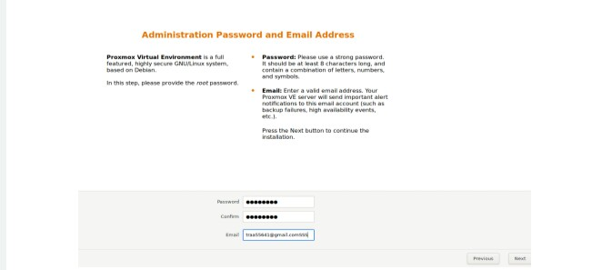

4.

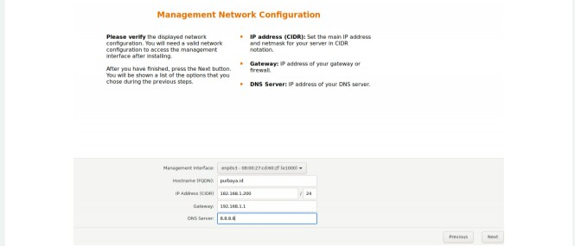

5.

